Introduction

In this report, you will be discussing the different aspects of the course. What kind of work you are doing currently, what units you do, etc..

User Requirements

In order to view this presentation, you will have to have a suitable internet connection and a computer.

Be able to speak clearly about different areas of the course.

Purpose

The purpose of this presentation is to educate Key Stage 4 students and Teachers of the students so they will be able to get insight to what is being taught on the course and how they can help each other.

Target Audience

The Target Audience is mainly Key Stage 4 students, and the Teachers of the pupils.
We are also aiming this at every learning age to make them aware of the trouble/issues of rainforest deforestation.

Tools

The tools that will are going to be required for the educational presentation that are going to be used are as follows:

· Microsoft Edge for the online research and gathering of information.

· PowerPoint for the main part of the presentation.

· Microsoft Word will be used for compiling the design report.

Asset Table
File Name | Content/Image | Description | Source/Reference
FE-Myth-Buster-Website-Facebook-image.jpg | 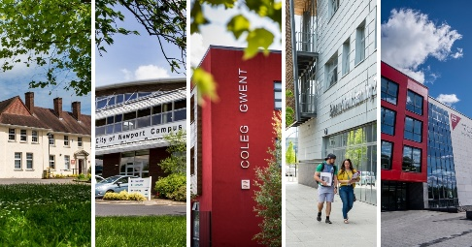 | Picture showing all 5 campuses in a row | * https://www.coleggwent.ac.uk/news/college-life-myth-buster-get-the-facts

